Find My Patient

Software documentation



|  |  |  |
| --- | --- | --- |
|  | By: | Shazil Khan  Gerard Klomphaar |
|  | Date: | 24-01-2016 |

Contents

Subject description 3

Subject analysis 4

Major features 4

Application Feasibility 4

Data description 4

Expected results 4

Algorithms study 4

Scope of the application (limits, evolutions) 4

Conception 5

Chosen algorithm 5

Data structures 5

Architecture 5

Global application flow 5

Global schema and major features schema 6

Console operations description 7

<One section by operation> 7

Configuration instructions 7

Commented Screenshots 7

Bibliography 7

# Subject description

This project is part of the Java course given at EPITA. To test and show a sufficient amount of knowledge a software application will be designed and developed.

As basis of the application the content created during the lectures will be used. The functionality will be extended where necessary to create the application.

In the subject analysis the requirements, features and results will be set.

The Conception chapter displays the design of the application.

# Subject analysis

The requirements for the project are subtracted from:

<http://www.thomas-broussard.fr/work/java/courses/project/fundamental.xhtml>

## Major features

The required features of the application are:

* **Access**, **create** and **modify** Identity information
* Persist **Identity** data in a database (or in an XML File) -> JDBC
* Be robust, capable of good performance
* Authentication, Login + password

Additional features:

* Propose a simple but efficient user interface

## Application Feasibility

… + Chosen Patient management system.

## Data description

## Expected results

## Algorithms study

|  |  |  |
| --- | --- | --- |
| **Subject** | **Description** | **Solution(s)** |
| Saving an POJO |  | JDBC, XML, File |
| Patient & User DAO |  | Template pattern |
| Searching patients |  | Strategy pattern |
| Business logic and View separation |  | MVC pattern |
| JDBC Connection management |  | Connection pool |
| User password security |  | Encryption |
| (optional)View update |  | Observer pattern |

## Scope of the application (limits, evolutions)

# Conception

## Chosen algorithm

## Data structures

## Architecture

(Devide)

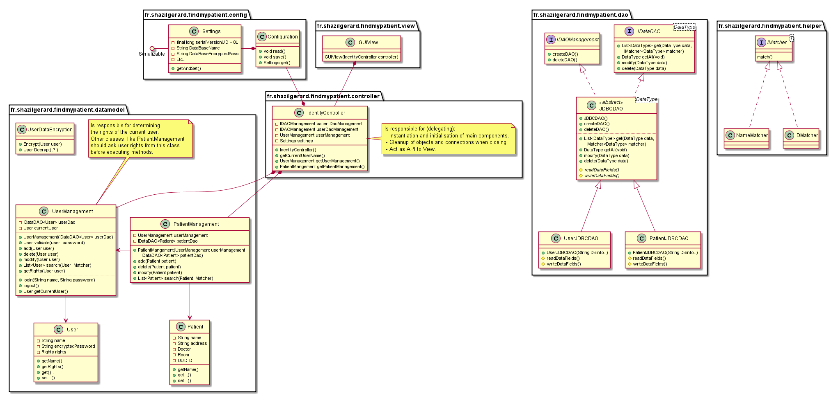

## Global application flow

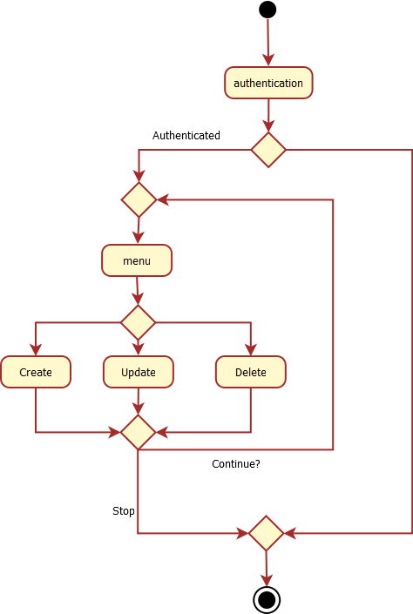

## Global schema and major features schema

# Console operations description

## <One section by operation>

# Configuration instructions

# Commented Screenshots

# Bibliography